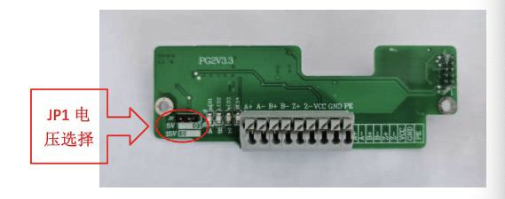

PG card user manual
1.Overview
This product is suitable for FR500A series inverters equipped with asynchronous
motors or synchronous motors equipped withABZ incremental encoder.
2. Product information
A. Technical specifications
Input power: 24V/200mA (provided by the control board)
Output power: 5V/200mA or 15V/100mA
Installation environment: indoor, no dust, corrosive gas, combustible gas, oil, water vapor, etc. Ambient temperature: -10°C ~ +50°C
Environmental humidity: less than 95%RH, no condensation
Vibration: less than 0.6G
B. Terminal function

Definition | Function instruction
A+ | Encoder input differential signal A
A-
B+ | Encoder input differential signal B
B-
Z+ | Encoder input differential signal Z
Z-
VCC | Output power supply
GND | Output power supply
PE | Ground terminal

Output power jumper wire selection: through the transformation of JP1, select the VCC output voltage as 5V or 15V

3. Installation and wiring:
Differential output encoder wiring method: connect the signal line and power line correspondingly, pay attention to the work voltage of the encoder.
Wiring method of open-drain NPN output encoder: signal wire ABZ is connected to A-, B- and Z- correspondingly.

4. Debugging method After installation and wiring, select the correct working voltage
according to the parameters on the encoder nameplate (VCC output 5V Or 15V).
After the inverter is powered on, set the parameters for debugging as follows:
1. Modify the F0-01 control mode to 1 (with PG vector control).
2. Modify the number of encoder lines F1-27 (there are instructions on the encoder).
3. When the motor is no-load, select parameter auto-tuning F1-37 option 2 to start motor parameter auto-tuning.
5. EMC Guidance
1.During on-site installation and commissioning, the signal line and power line need to be routed
in different troughs. Encoders lines are strictly prohibited to bundle with the power cables and
route them together, otherwise the encoder interference problem is prone to occur.
2.The motor shell must be connected to the ground terminal (PE terminal) of the inverter, and the
ground line on the side of the motor shell must be well connected; otherwise, a good grounding
effect will not be achieved.
3.It is recommended to use twisted-pair cables. For differential encoders, twisted-pair cables must
be wired as differential pairs.
The shielding layer is connected to the ground terminal (PE terminal) of the inverter. 4. For some
large-scale equipment, the inverter is far away from the motor, and the motor cable length is greater than 10 meters.
The grounding effect will be worse due to the influence of inductance. In this case, the shielding
layer of the encoder can be disconnected from the grounding terminal of the inverter.

